Chapter 3
3.1 Sampling Ditributions
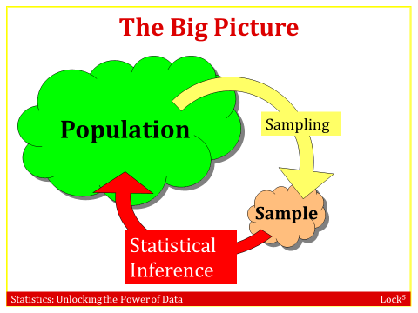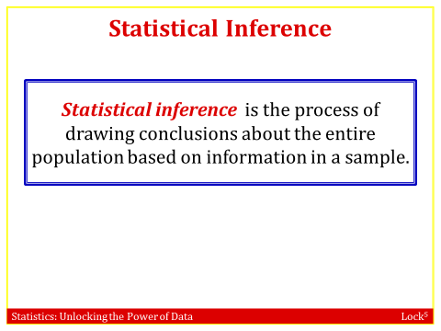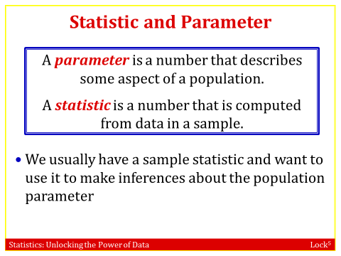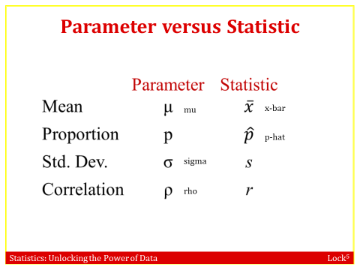
Example:
For each of the following, state whether the quantity described is a parameter or a statistic, and give the correct notation.
  - Average household income for all houses in the US, using data from the US census Parameter, (symbol µ)
  - Correlation between height and weight for players on the 2014 Brazil world cup team, using data from all 23 players on the roster
Parameter (symbol ρ)
  - Proportion of people who use an electric toothbrush, using data from a sample of 300 adults Statistic (symbol )

Example 1: Using Search Engines on the Internet
A 2012 survey of a random sample of 2253 US adults found that 1,329 of them reported using a search engine (such as Google) every day to find information on the Internet.

a). Find the relevant proportion and give the correct notation with it.
b). Is your answer to part (a) a parameter or a statistic? Statistic

c). Give notation for and define the population parameter that we estimate using the
Result of part (a).
p = the proportion of all US adults that would report that they use an Internet search engine every day

Example 2: Number of Books Read in a Year
A survey of 2,986 Americans ages 16 and older found that 80% of them read at least one book in the last year. Of these book readers, the mean number of books read in the last year is 17 while the median number of books read in the last year is 8.

a). How many “book readers” (defined as reading at least one book in the past year) were included in the sample?
Number of book readers is 0.80(2986) = 2388.8 or about 2389 book readers.
b). Why might the mean and median be so different? Using the information given about the mean and median number of books read in a year, what is the likely shape of the distribution of number of books read in a year by book readers?
Since the mean is so much larger than the median, it is likely that there are some very large outliers. The distribution is probably skewed to the right.
c). Give the correct notation for the value “17” in the information above. Is this value a parameter or a statistic?
It is a statistic and the correct notation for a sample mean is .
d). Give notation for and define the population parameter that we estimate using the result of part (c).
μ = the mean number of books read last year by all Americans ages 16 and older who have read at least one book. [Emphasize that we are estimating the mean of the population.]
We have a problem. Usually we want to know the value of the parameter but we can only obtain the statistic. We need a way to use the statistic to tell us something about the parameter.

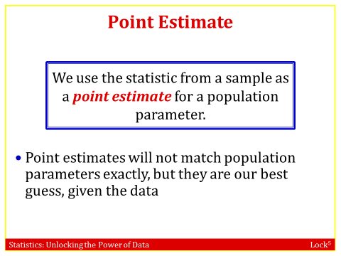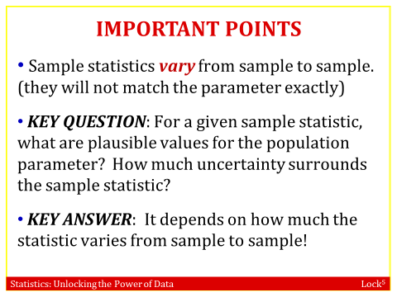
To see how statistics, vary from sample to sample, we will take many samples and compute many statistics!

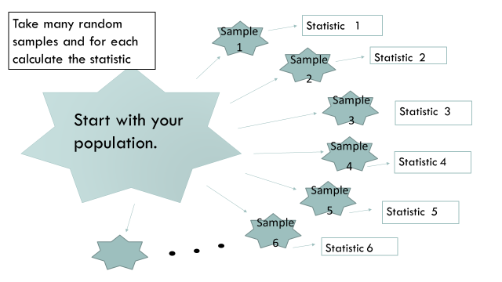

Let’s look at an example to illustrate the process:

Suppose we are interested in STA 296 students would like to know the proportion of those students that had trouble getting the required books.

Population: All STA 296 Students
Parameter: The proportion of all STA 296 that had trouble getting the book, we can denote it using the letter p.

Suppose I take a random sample of 25 STA 296 students and I find that 4 of the 25 students had trouble. Notice the type of statistic I will calculate is a sample proportion.

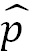= 4/25=.16
We could also say the point estimate is equal to .16

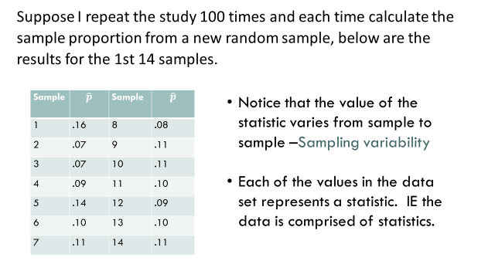
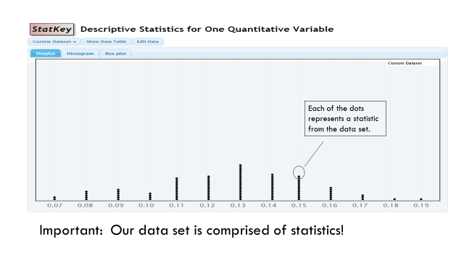
A Sampling Distribution is the distribution of sample statistics computed for different samples of the same size from the same population. A sampling distribution shows us how the sample statistic varies from sample to sample.

Properties of Sampling distribution:
- Center: If samples are randomly selected, the sampling distribution will be centered around the population parameter.
- Shape: For most of the statistics we consider, if the sample size is large enough the sampling distribution will be symmetric and bell-shaped.
- 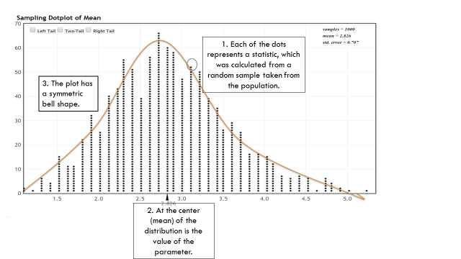
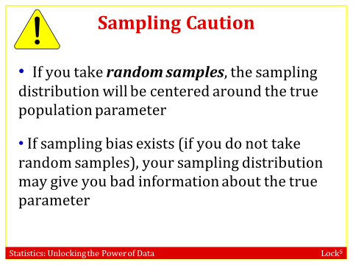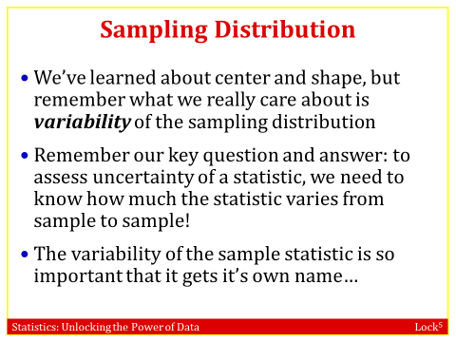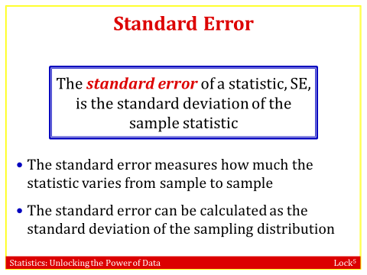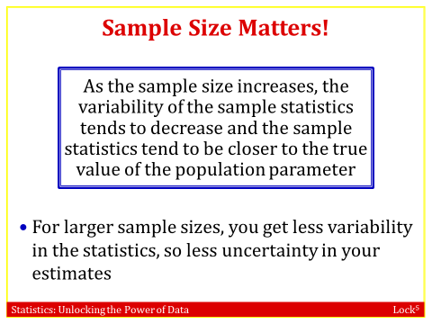
How can do we create sampling distributions?
Use the following steps to plot the data in StatKey.
- Go to: http://www.lock5stat.com/StatKey/
- Click on Sampling Distribution

We can estimate the standard error by looking at the sampling distribution by applying the Empirical Rule. Your text book gives an abbreviated version of the empirical rule called the 95% rule.

The empirical rule can be applied to any bell shaped distribution. It states the following ….
- 68 % of data falls within the first standard deviation from the mean.
- 95% fall within two standard deviations.
- 99.7 % fall within three standard deviations.
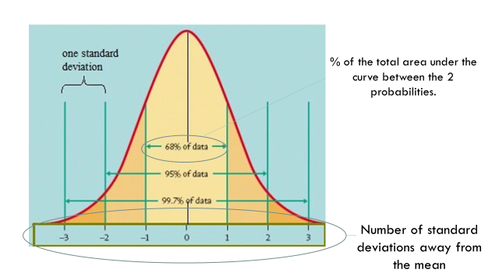
Example 3: Proportion Never Married
A sampling distribution is shown for the proportion of US citizens over 15 years old who have never been married, using the data from the 2010 US Census and random samples of size n = 500.

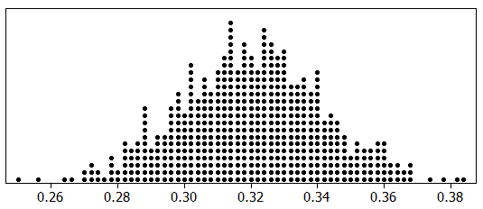

a). What does one dot in the dotplot represent?
One dot represents the proportion of people who have never been married in one sample of 500 people.
b). Use the sampling distribution to estimate the proportion of all US citizens over 15 years old who have never been married. Give correct notation for your answer.
We are estimating the population parameter p and we know that the sampling distribution is centered at the population parameter, so we estimate that p ≈ 0.32.
c). If we take a random sample of 500 US citizens over 15 years old and compute the proportion of the sample who have never been married, indicate how likely it is that we will see that result for each sample proportion below. We see how likely the given sample proportion is to occur in a sample of size 500

Likely to occur Very unlikely to occur Not very likely but possible VERY unlikely!
The idea is just to get the students thinking about what is likely to happen by random chance.
d). Estimate the standard error of the sampling distribution.
We use the 95% rule to give a rough estimate of SE ≈ 0.02.
e). If we took samples of size 1000 instead of 500, and used the sample proportions to estimate the population proportion:

Would the estimates be more accurate or less accurate? More accurate

Would the standard error be larger or smaller? Smaller

Quick Self-Quiz: Effect of Sample Size
Three different sampling distributions A, B, and C are given for a population with mean 50. One corresponds to samples of size n = 25, one to samples of size n = 100, and one to samples of size n = 400. Match the sampling distributions with the three sample sizes, and estimate the standard error for each.
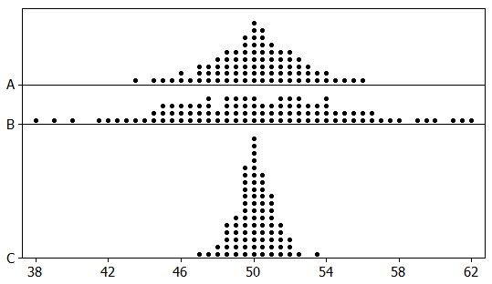
We know that the standard error goes down as the sample size goes up, so we match distribution
A with n = 100
B with n = 25
C with n = 400
We give a rough estimate of the standard error in each case using the 95% rule:
A: SE ≈ 2 B: SE ≈ 4 C: SE ≈ 1

3.2 : Understanding and Interpreting Confidence Intervals
Notice that creating a sampling distribution requires us to take many samples from the population. In the real word we only get to take one sample from the population to help us estimate the parameter. There are 2 issues we need to address:
- We know that the value of the statistic changes from sample to sample. How can we use a single number to estimate a parameter? –Section 3.2
- Also since we only get one sample how do we estimate the variability of the statistic? –Section 3.3

- A point estimate doesn’t tell us how close the estimate is likely to be to the parameter
- An interval estimate is more useful
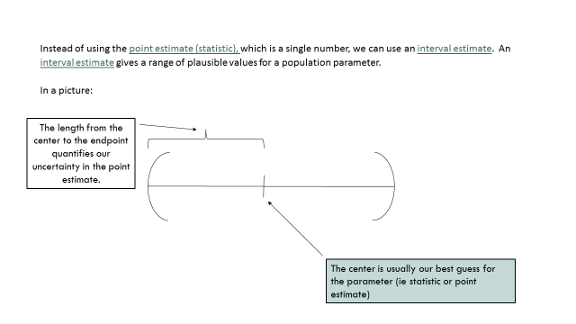
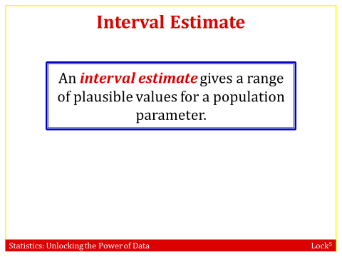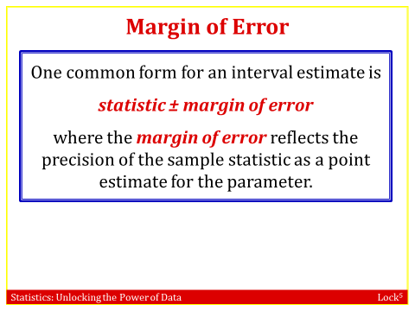
The margin of error measures how accurate the point estimate is likely to be in Estimating a parameter

Example: “Forty-five percent of American adults reported getting their health insurance from an
employer…” Later in the report, it says “the maximum margin of sampling error is ±1
percentage point”
Interval estimate: 45% ± 1% = (44%, 46%)
The percentage of American adults getting their health insurance from an employer is probably between 44% and 46%

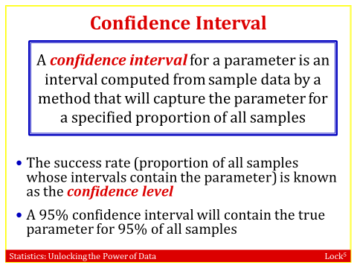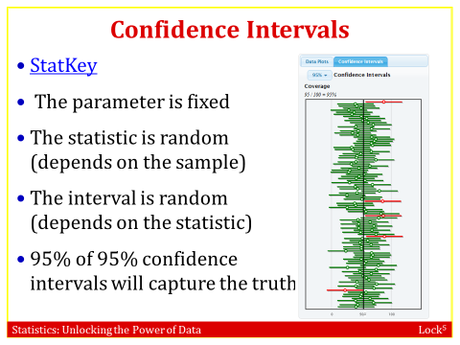
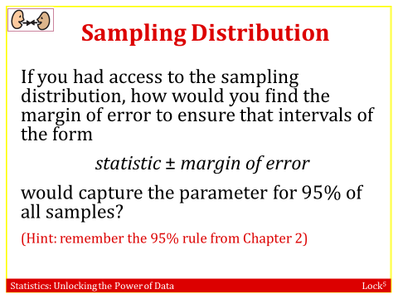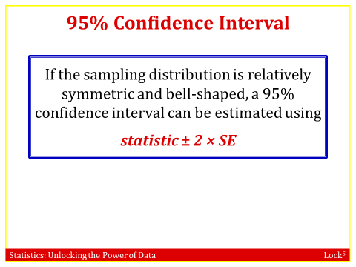

Example: A survey of 1,502 Americans in January 2012 found that 86% consider the economy a “top priority” for the president and congress.The standard error for this statistic is 0.01.

What is the 95% confidence interval for the true proportion of all Americans that considered the economy a “top priority” at that time?

statistic ± 2×SE= 0.86 ± 2×0.01=0.86 ± 0.02=(0.84, 0.88)
Interpreting a Confidence Interval:
- 95% of all samples yield intervals that contain the true parameter, so we say we are “95% sure” or “95% confident” that one interval contains the truth.
- “We are 95% confident that the true proportion of all Americans that considered the economy a ‘top priority’ in January 2012 is between 0.84 and 0.88”
Example: Constructing Confidence Intervals
For each of the following, use the information to construct a 95% confidence interval and give notation for the quantity being estimated.
(a) With standard error 0.04
Estimating p. Interval is 0.72 ± 2(0.04), giving 0.64 to 0.80.

(b)with standard error 3.2.
Estimatingμ.. Interval is 27 ± 2(3.2), giving 20.6 to 33.4.

(c) With margin of error for 95% confidence of 0.02
Estimating the difference in proportions . Interval is 0.05 ± 0.02, giving 0.03 to 0.07.
Example: Adopting a Child in the US
A survey of 1,000 American adults conducted in January 2013 stated, “44% say it’s too hard to adopt a child in the US.” The survey goes on to say that, “The margin of sampling error is +/- 3 percentage points with a 95% level of confidence.”
- What is the relevant sample statistic? Give appropriate notation and the value of the statistic.
- What population parameter are we estimating with this sample statistic?
p = the proportion of all American adults who say it is too hard to adopt a child in the US
- Use the margin of error to give a confidence interval for the estimate.
0.44 ± 0.03 gives an interval from 0.41 to 0.47
- Is 0.42 a plausible value of the population proportion? Is 0.50 a plausible value?
0.42 lies in the interval so is a plausible value, but 0.50 is not a plausible value.
Example: Budgets of Hollywood Movies
A sampling distribution is shown for mean budget (in millions of dollars) of movies to come out of Hollywood in 2011, using samples of size n = 20. We see that the standard error is about 10.23. Find the following sample means in the distribution and use the standard error 10.23 to find the 95% confidence interval given by each of the sample means listed. Indicate which of the confidence intervals successfully capture the true population mean of 53.48 million dollars (for all 134 movies).
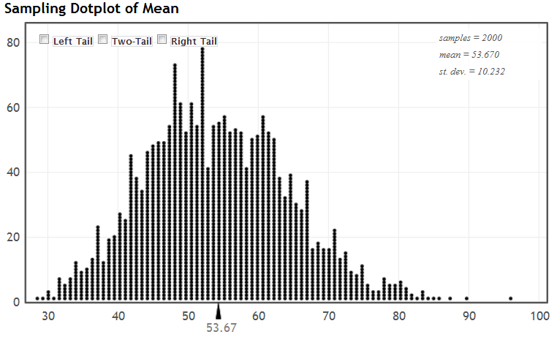
(a)
40 ± 2(10.23) gives
19.54 to 60.46. Does contain population mean.
(b)
70 ± 2(10.23) gives
49.54 to 90.46. Does contain population mean.
(c)
84 ± 2(10.232) gives
63.54 to 104.46. Does not contain population mean.[Note that is quite far in the tail of the sampling distribution.]
Interpretation of a Confidence Interval
- 95% of all samples yield intervals that contain the true parameter, so we say we are “95% sure” or “95% confident” that one interval contains the truth.
- “We are 95% confident that the true proportion of all Americans that considered the economy a ‘top priority’ in January 2012 is between 0.84 and 0.88”
Common misinterpretation of a Confidence Interval
- Misinterpretation 1: “A 95% confidence interval contains 95% of the data in the population”
The interpretation needs to refer to the location of the parameter not the data.
- Misinterpretation 2: “I am 95% sure that the mean of a sample will fall within a 95% confidence interval for the mean”
The interpretation needs to refer to the location of the parameter not the statistic.

- Misinterpretation 3: “The probability that the population parameter is in this particular 95% confidence interval is 0.95”
The parameter is a single fixed number, this is saying the parameter is random

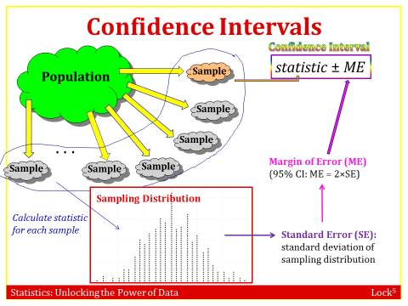

Quick Self-Quiz: Interpreting a Confidence Interval
Using a sample of 24 deliveries described in “Diary of a Pizza Girl” on the Slice website, we find a 95% confidence interval for the mean tip given for a pizza delivery to be $2.18 to $3.90. Which of the following is a correct interpretation of this interval? Indicate all that are correct interpretations.
a). I am 95% sure that all pizza delivery tips will be between $2.18 and $3.90.
Incorrect. The interval is about a parameter (a summary of a population, mean here), not the individual values in the population (which is what this interpretation is referring to).
b). 95% of all pizza delivery tips will be between $2.18 and $3.90.
Incorrect. The interval is about the mean, not individual tips.
c). I am 95% sure that the mean pizza delivery tip for this sample will be between $2.18 and $3.90.
Incorrect. The interval is about the mean of the population, not a sample mean.
d). I am 95% sure that the mean tip for all pizza deliveries in this area will be between $2.18 and $3.90. Correct!
e). I am 95% sure that the confidence interval for the mean pizza delivery tip will be between $2.18 and $3.90.
Incorrect. The confidence is in where the population mean is, not where the interval itself is.
3.3: Constructing Bootstrap Confidence Intervals
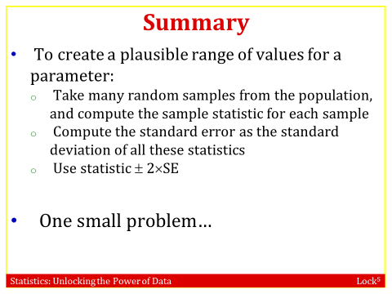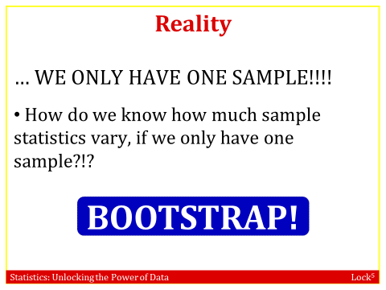
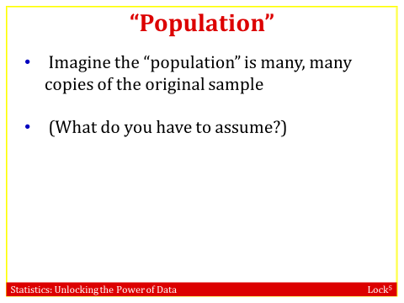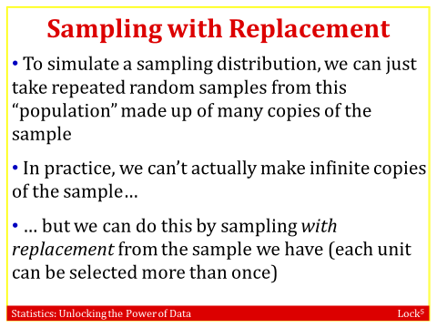
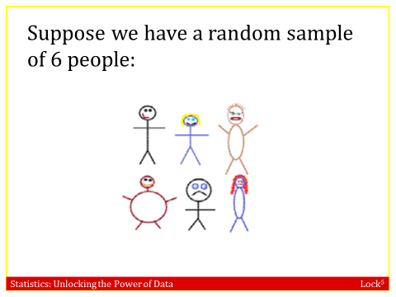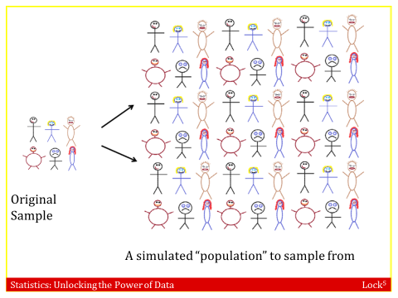
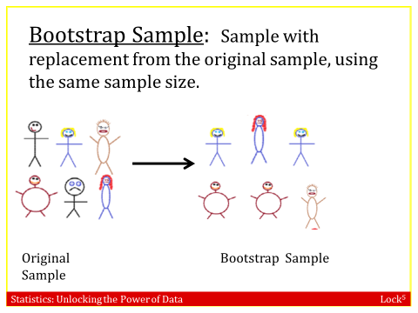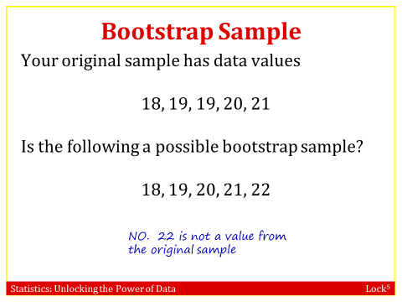
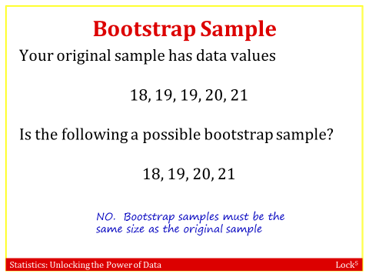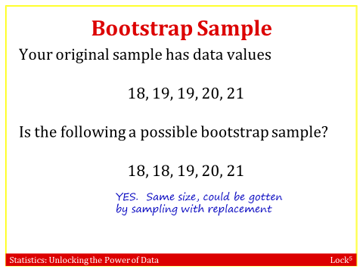
Example 1: Textbook Prices
Prices of a random sample of 10 textbooks (rounded to the nearest dollar) are shown:
$132 $87 $185 $52 $23 $147 $125 $93 $85 $72

a). What is the sample mean?
b). Describe carefully how we could use cards to create one bootstrap statistic from this sample. Be specific.
We use 10 cards and write the 10 sample values on the cards. We then mix them up, draw one, record the value on it, and put it back. Mix them up again, draw another, record the value, and put it back. Do this 10 times. Then compute the sample mean of this bootstrap sample.
c). Where will be bootstrap distribution be centered? What shape do we expect it to have?
It will be centered approximately at the sample mean of 100.1 and we expect it to be bell-shaped.

Example 2: Reese’s Pieces
We wish to estimate the proportion of Reese’s Pieces that are orange, and we have one package of Reese’s Pieces containing 55 pieces. Describe carefully how we can use this one sample to create a bootstrap statistic. Be specific.
Mix up the pieces and pull one out and record whether or not it is orange and then put it back. Mix them up again, pull one out again and record whether or not it is orange. Put it back and continue the process until we have recorded the result for 55 pieces sampled this way. Compute the proportion of orange candies from this bootstrap sample.
Quick Self-Quiz: Bootstrap Samples
A sample consists of the following values: 8, 4, 11, 3, 7.
Which of the following are possible bootstrap samples from this sample?
a). 8, 3, 7, 11 No because the sample size does not match.
b). 4, 11, 4, 3, 3 Yes.
c). 3, 4, 5, 7, 8 No, because 5 is not in the original sample.
d). 7, 8, 8, 3, 4 Yes.
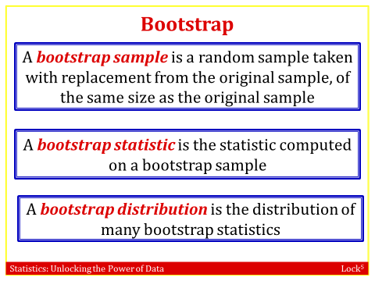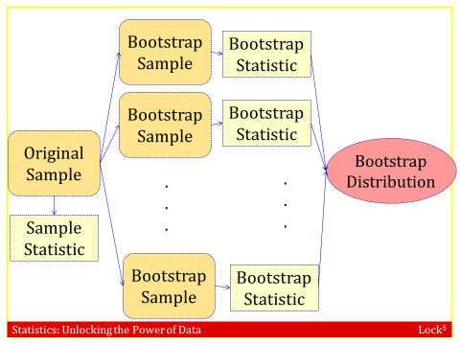
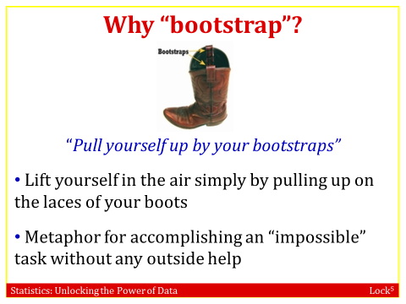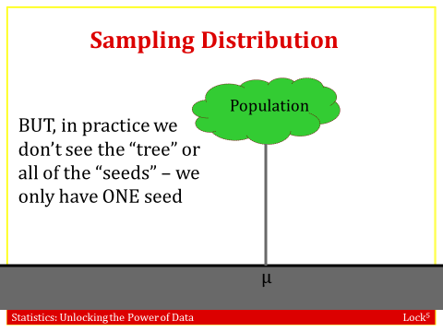

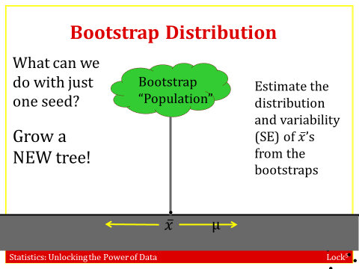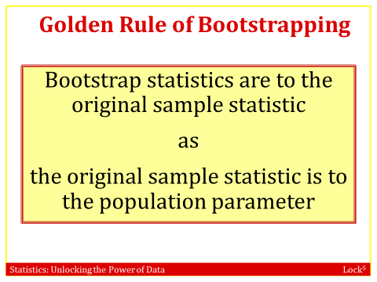
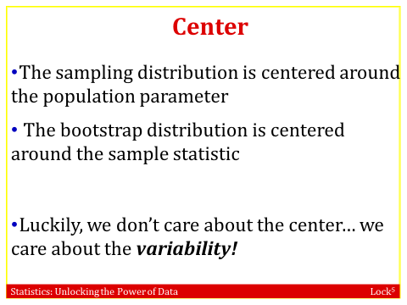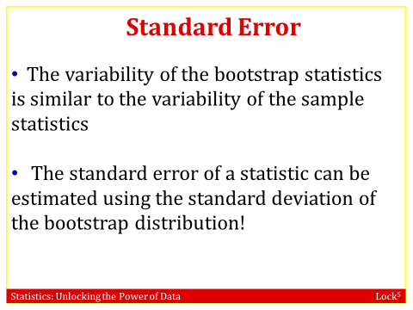
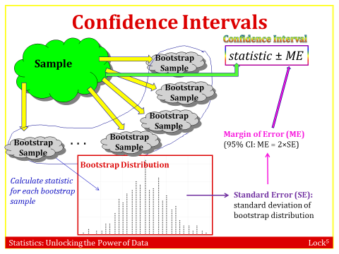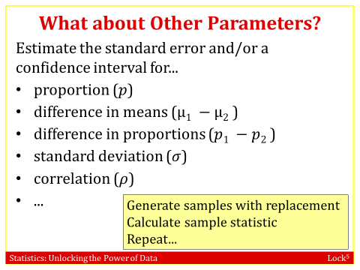

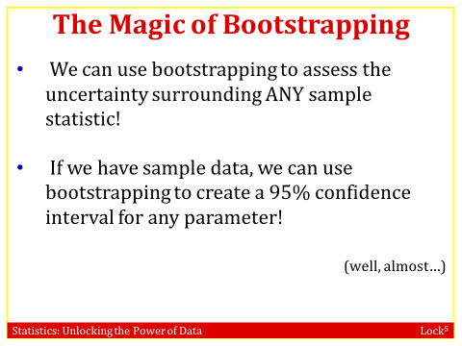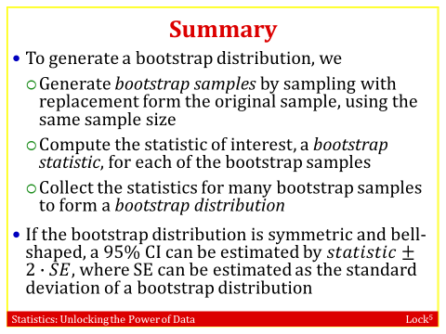
Example : Global Warning by Political Party
Does belief in global warming differ by political party? When the question “Is there solid evidence of global warming?” was asked, the sample proportion answering “yes” was 79% among Democrats and 38% among Republicans. A bootstrap distribution for the difference in proportions () is shown (assuming samples of size 1000 from each party). Use the information there to give a 95% CI for the difference in proportions.

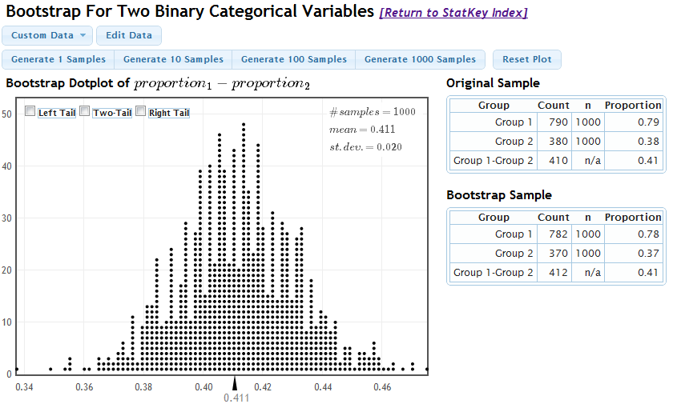
The sample difference in proportions is 0.79 – 0.38 = 0.41 and the standard error from the bootstrap distribution is 0.020 so we compute the 95% confidence interval using 0.41 ± 2(0.020), giving an interval of 0.37 to 0.45. We are 95% confident that the proportion of Democrats who believe there is solid evidence of global warming is between 0.37 and 0.45 higher than the proportion of Republicans who believe this.

Example : Global Warming
What percentage of Americans believe in global warming? A survey on 2,251 randomly selected individuals conducted in October 2010 found that 1,328 answered Yes to the question “Is there solid evidence of global warming?” A bootstrap distribution for this data is shown. Use the information there to give and interpret a 95% CI for the proportion of Americans who believe there is solid evidence of global warming.
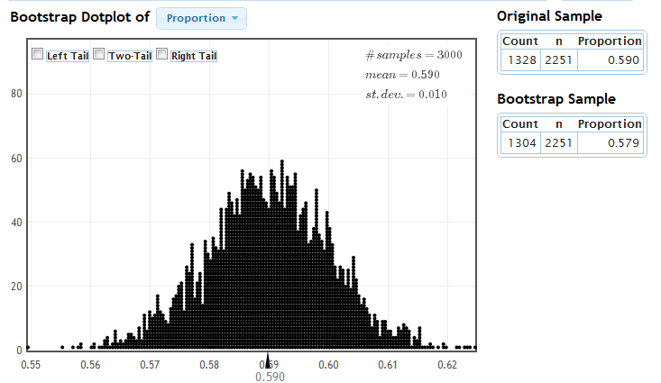
The sample proportion is 0.590 and the standard error from the bootstrap distribution is 0.010 so we compute the 95% confidence interval using 0.590 ± 2(0.010), giving an interval of 0.57 to 0.61. We are 95% confident that the proportion of Americans who believe there is solid evidence of global warming is between 0.57 and 0.61.

3.4 : Bootstrap Confidence Intervals using Percentiles
In the previous sections we looked at how to construct a 95% confidence interval,
where we estimated the SE by using the sampling distribution or the bootstrap
distribution. In this section we are going to look at how to create a confidence
interval for any level of confidence using a bootstrap distribution.

. 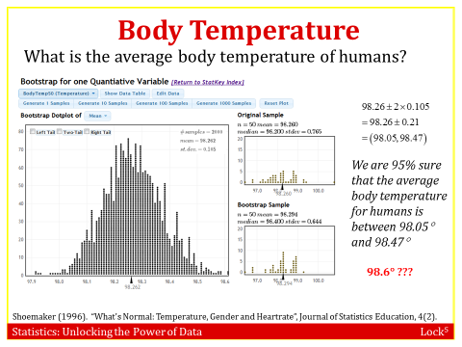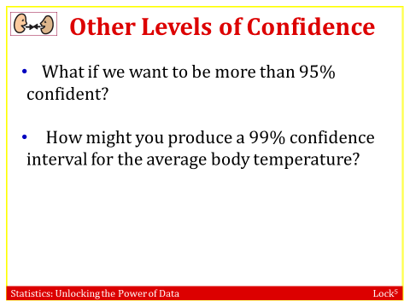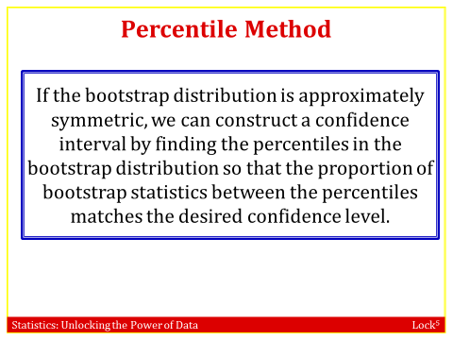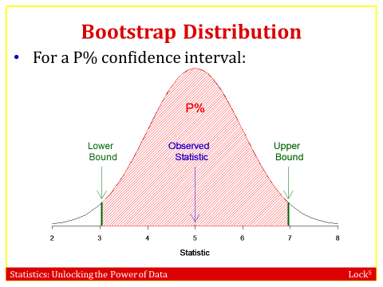 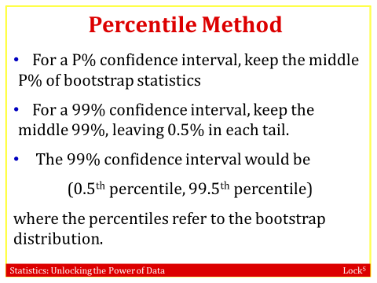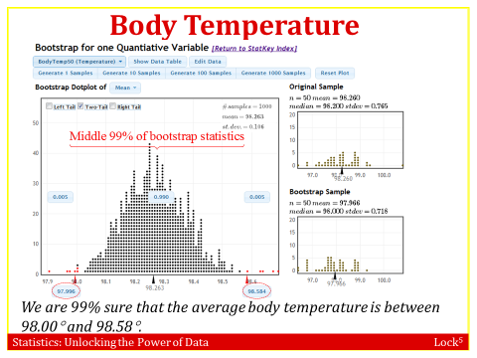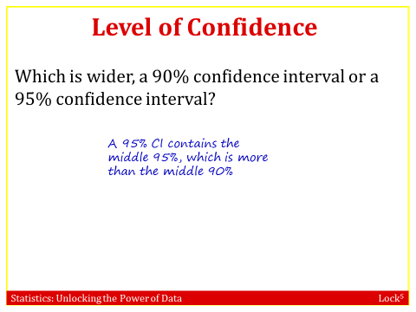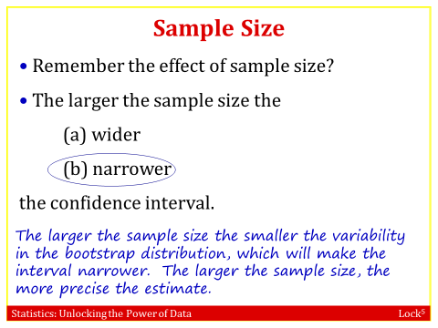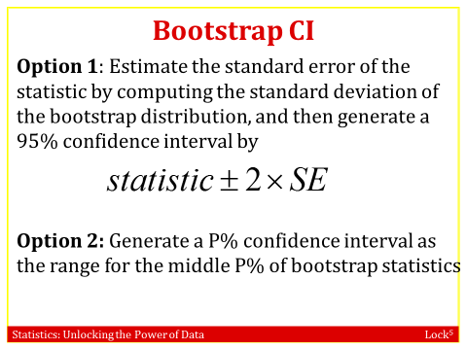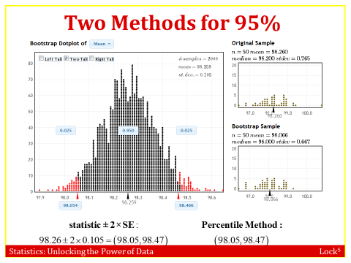
Example: Body Temperature
Is normal body temperature really 98.6 ◦F? A sample of body temperature for 50 healthy individuals was taken. Find this dataset in StatKey under “Confidence Interval for a Mean” or as BodyFat50 in the text’s datasets.
- What is the sample mean? What is the sample standard deviation?
Mean = 98:26 and standard deviation = 0:765
- Generate a bootstrap distribution, using at least 1000 simulated statistics. What is the standard error?
SE ≈ 0:105. Answers will vary slightly with different simulations.
- Use the standard error to find a 95% confidence interval. Show your work. Is 98.6 in the interval?
x±2 · SE = 98:26±2(0:105), which gives the interval 98.05 to 98.47. We see that 98.6
is not in the interval.
- Using the same distribution, find a 95% confidence interval using the “Two-tail” option on StatKey (or other technology to give percentiles from the bootstrap distribution).
98.05 to 98.47. Answers will vary slightly with different simulations
(e) Compare the two 95% confidence intervals you found. Are they similar?
Yes, very similar.
(f) Still using the same bootstrap distribution, give a 99% confidence interval. 97.98 to 98.54
(g) Is the 99% confidence interval wider or narrower than the 95% confidence interval? Wider
(h) Clearly interpret the 99% confidence interval
We are 99% sure that the mean body temperature for all healthy individuals is between
98.017 and 98.544.
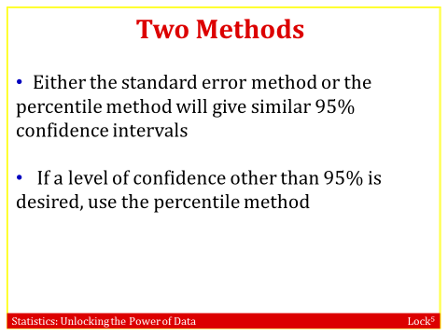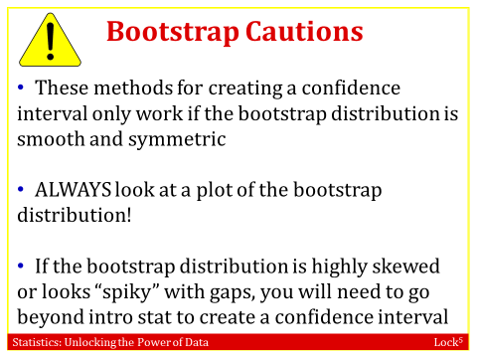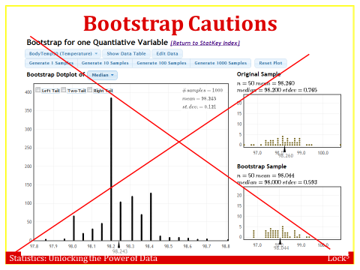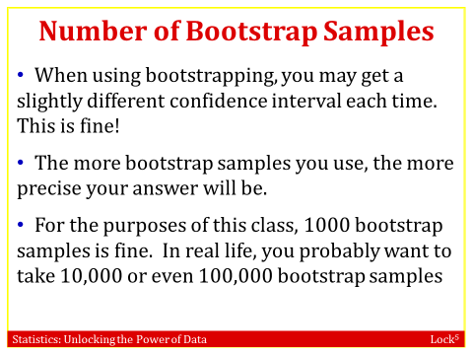

Example: Problems with Bootstrap Distributions
If a bootstrap distribution is not relatively symmetric, it is not appropriate to use the methods of this chapter to construct a confidence interval. Consider the following data set: 5, 6, 7, 8, 25, 100 (a) What is the standard deviation of this dataset? s = 37:413

(b) Use StatKey (or other technology) to create a bootstrap distribution for the standard deviation of this dataset. Describe the distribution. Is the distribution symmetric and bell-shaped?
It is not at all symmetric or bell-shaped. There are four separate sharp peaks and the
distribution is strongly skewed to the right.
(c) Is it appropriate to use the methods of this section to find a bootstrap confidence interval for this standard deviation?
No, we should only use the methods of this section when the bootstrap distribution is
roughly symmetric.
(d) Discuss with a neighbor why the bootstrap distribution might look the way it does.
There are two outliers in this dataset, and the standard deviation from a bootstrap
sample will be dramatically different depending on how many copies of each outlier get
selected.

